

JUNIOR CLUB CHAMPS PROGRAMME 2018
AGE AS AT 31/12/2017

6th March 2018
13th March 2018

Warm up

3 year old girls 30m – Straight Final
3 year old boys 30m – Straight Final
4 year old girls 30m – Straight Final
4 year old boys 30m – Heats
4 year old boys 30m – Final

3 year old girls 60m – Straight Final
3 year old boys 60m – Straight Final
4 year old girls 60m – Straight Final
4 year old boys 60m – Heats
4 year old boys 60m – Final

May leave after races are complete

5 year old girls 50m – Heats
5 year old boys 50m – Heats
6 year old girls 50m – Heats
6 year old boys 50m – Heats
5 year old girls 50m – Finals
5 year old boys 50m – Finals
6 year old girls 50m – Finals
6 year old boys 50m – Finals

5 year old girls 75m – Heats
5 year old boys 75m – Heats
6 year old girls 75m – Heats
6 year old boys 75m – Heats
5 year old girls 75m – Finals
5 year old boys 75m – Finals
6 year old girls 75m – Finals
6 year old boys 75m – Finals

End of programme

Club Champs Officials:
Anne Lawson (Recorder)
Tina Tucker
Tim Mclean
Tania Mclean
Brian Dettling (Starter)
Stephanie Courtenay

Warm up

3 year old girls 50m – Straight Final
3 year old boys 50m – Straight Final
4 year old girls 50m – Straight Final
4 year old boys 50m – Heats
4 year old boys 50m – Final

3 year old girls 75m – Straight Final
3 year old boys 75m – Straight Final
4 year old girls 75m – Straight Final
4 year old boys 75m – Heats
4 year old boys 75m – Final

May leave after races are complete

5 year old girls 60m – Heats
5 year old boys 60m – Heats
6 year old girls 60m – Heats
6 year old boys 60m – Heats
5 year old girls 60m – Finals
5 year old boys 60m – Finals
6 year old girls 60m – Finals
6 year old boys 60m – Finals

5 year old girls 100m – Heats
5 year old boys 100m – Heats
6 year old girls 100m – Heats
6 year old boys 100m – Heats
5 year old girls 100m – Finals
5 year old boys 100m – Finals
6 year old girls 100m – Finals
6 year old boys 100m – Finals

End of programme

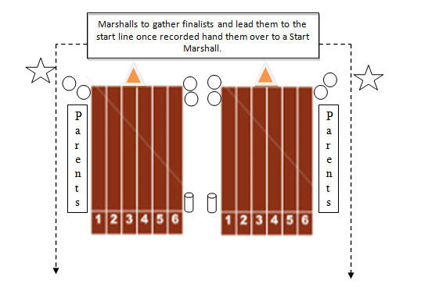
Club Champs Marshalling Roles & Duties
KEY
= Recorder = Starter = Place getter

PLACINGS: Red Peg – 1st Blue Peg – 2nd Green Peg – 3rd Yellow Peg – 4th

All marshals need to wear a Hi Vis Vest (Collect from Shed)
- Line marshals stand 1m back from the finish line, gather place getters and lead them back to start line. (Keep parent observers off the track)
- Recorder & Start Marshal to indicate start of race by raising a single arm
- Recorder must record heat/final placing’s 1 – 5 + 1st place times.
- First place requires two timers (Record the average time of both)
- Start marshal’s co-ordinate race starts. Checking that the children are in right uniform and are in the right race.
- Start marshal’s x 2 including starter to observe for false starts. If a false start occurs a single arm must be raised, the starter must double clap to stop race.

